FlyQuickActions Restructuring Spec — RC-Primary Quad/FW
Sep 29, 2026 · @elsa

Summary & Design Principles
For RC-primary quadcopters and fixed-wing aircraft, RC is the arming and flight-control authority; the GCS Fly view's job is monitoring and situational awareness, plus (separately) bench-test authority for ground checks. Force Arm, Takeoff, and Return on the current FlyQuickActions.qml don't fit that model as built, and none of the three currently work reliably.
Design principles this spec follows:
- Don't duplicate RC. An action RC-primary control already performs (arming, sustained flight commands) doesn't belong on the Fly view — a second, weaker-authority GCS path to the same action adds risk without adding capability.
- Split by failure direction. Arm and Takeoff fail toward hazard (they move the vehicle into a state it wasn't in). RTL fails toward safety (it moves the vehicle toward home and a known altitude). Hazard-direction actions are removed or strictly gated; safety-direction actions can be kept and hardened.
- Force-arm is a bench capability, not a flight capability. Its UI belongs where motor and control-surface ground tests already live, not on the primary Fly view.
- One code path per action. Whatever the Fly view keeps routes through a single function, gated the same way arm commands are already gated at the Vehicle-level chokepoint (setArmCommandInterceptor / ArmingGate::makeArmInterceptor) — no parallel QML-to-C++ paths.
- No change to existing arm-gate logic. This spec relocates and hardens UI entry points; it does not touch the interceptor, the fail-closed semantics, or the bounded-override mechanism already implemented and tested.
Scope: quadcopter and fixed-wing vehicles operating with RC as the primary control input. VTOL and any future telemetry-link-primary (BVLOS) profile are explicitly out of scope — see Open Questions.

Force Arm — Remove from Fly View, Relocate to Bench Test
Current state. The Force Arm control on FlyQuickActions.qml is unreliable, and the investigation behind this spec found the underlying gate wiring inconsistent across callers: TelemetryBridge::forceArm() opens a bounded, logged override before sending, but VehicleProfileManager::forceArm() calls vehicle->forceArm() directly with no override and no log, and HardwareTestController's fixed-wing auto-arm flow sends the legacy force-arm parameter with no gate interaction at all. Three different force-arm behaviors exist today under one label.
Why it doesn't belong on the Fly view. Force-arm's only legitimate use in this codebase is bench testing — spinning motors or sweeping control surfaces on the ground to verify hardware before flight. That's a maintenance action performed on a stationary, disarmed vehicle, not a flight action. Sitting on the primary Fly view, it's a second arming path a pilot's thumb can hit by accident, next to controls meant for airborne operation.
Where it moves. A new or extended Bench Test panel, alongside the existing MotorCheckPanel.qml and control-surface sweep UI (GimbalTest.qml, which superseded the dead ControlSurfacePanel.qml). This panel should carry an explicit "Ground Test Mode" banner and require a two-step confirm (hold-to-confirm or type-to-confirm, not a single tap), since props may still be attached during a motor test.
Required backing changes (all three force-arm callers converge on one path):
- VehicleProfileManager::forceArm() — stop calling vehicle->forceArm() directly; route through the same bounded, logged ArmingGate override that TelemetryBridge::forceArm() already uses.
- HardwareTestController's fixed-wing auto-arm flow — open the bounded override before sending, instead of sending the legacy force-arm parameter directly.
- Add a pre-condition check on the new Bench Test panel's force-arm control: refuse to arm if the vehicle reports non-zero groundspeed or a recent-takeoff/landed-state mismatch, as a defense against force-arming an aircraft that's actually airborne.
- Remove any force-arm affordance from MainStatusIndicator.qml, ArmedIndicator.qml, and PreflightToolbarIndicator.qml — these are flight-context indicators and shouldn't carry a bench-test action, regardless of which of them the running app actually loads (see File-by-File Changes on the QML-shadowing issue already found in MainStatusIndicator).

Takeoff — Remove from Default Fly View
Current state. Takeoff and Return share an implementation pattern on FlyQuickActions.qml (both were added routing through TelemetryBridge's takeoff()/rtl() in the same change). Takeoff isn't working reliably and, more importantly, doesn't belong next to Return once the two are evaluated on their own merits — this section separates them.
Why it comes off the default view. GCS-commanded takeoff is a guided-mode autonomy feature. If RC is primary, the pilot advances the throttle — no button needed. The real risk isn't that the button doesn't work; it's dual-authority confusion: a pilot standing there with RC in hand, expecting to fly manually, while a tap on the GCS commands a climb-out nobody asked for. That's worse than a non-functional button.
This phase: delete, don't gate. For quad/FW RC-primary craft, remove the Takeoff control and its handler from FlyQuickActions.qml entirely. Do not build a gated "autonomous ops" version as part of this spec — see Open Questions for whether that's needed at all before scoping it as separate work.
If a future need arises (scripted survey launch, VTOL transition — out of scope here), it should live behind an explicit, off-by-default "Autonomous Ops" mode with distinct visual treatment (a separate tab or clearly differentiated section, never inline with manually-flown controls), and its backing TelemetryBridge::takeoff() call should check both armingAllowed/overrideActive and the autonomous-mode flag before sending.

Return-to-Launch — Keep and Harden
Why RTL stays. Its failure direction is the opposite of arm and takeoff: an accidental trigger is disruptive but fails toward safety — climb to a configured altitude and return home, not into a hazard. RTL also serves a real RC-primary use case: an observer or safety pilot watching the GCS can trigger it as a backstop if the flying pilot loses orientation or the link degrades, without needing to take the transmitter.
Hardening requirements before this ships:
- Single code path. RTL button → one function (e.g. TelemetryBridge::returnToLaunch()) → the vehicle's guided-RTL command, with no parallel or duplicate implementation. Split this cleanly from Takeoff's current shared plumbing.
- Confirmation. A held-press or two-step confirm, showing current altitude and distance-to-home at the moment of trigger, not a single tap.
- Logging. Every trigger logged with timestamp, triggering session, and vehicle state (altitude, groundspeed, distance-from-home) to the existing compliance log, consistent with the flight-session logging already in place.
- Real feedback, not assumed feedback. The button should reflect an actual mode-change acknowledgment (RTL confirmed via heartbeat), not just "command sent" — this project has already found more than one place where a status was assumed rather than verified.
- Availability independent of preflight checks. RTL should be enabled based on connection state alone, not gated by ArmingGate/preflight-check status — it needs to work precisely in situations where something else is already going wrong.

Resulting Fly View — Monitoring Surface
With Force Arm and Takeoff removed, the Fly view for RC-primary quad/FW becomes a monitoring surface backed by TelemetryBridge, ChecklistEngine/PreflightManager, and ArmingGate — all read-only from the UI's perspective, plus the single hardened RTL trigger.
Widget | Data source | Display | Priority
Battery % / voltage / current | TelemetryBridge battery properties | Numeric + estimated remaining flight time | Always visible
GPS fix type / satellite count | TelemetryBridge GPS properties | Icon + count | Always visible
RC link quality / RSSI | TelemetryBridge RC properties | Bar/percentage | Always visible
Telemetry link quality | TelemetryBridge connection state | Bar/percentage | Always visible
Altitude, airspeed/groundspeed, heading | TelemetryBridge | Numeric strip | Always visible
Distance from home | TelemetryBridge / VehicleProfileManager | Numeric | Always visible
Armed/disarmed state | Vehicle::armed() via TelemetryBridge | Read-only badge | Always visible
Flight mode | Vehicle heartbeat-derived mode | Read-only label — reflects RC mode-switch selection, GCS never sets it here | Always visible
Attitude / artificial horizon | TelemetryBridge IMU properties | Standard ADI widget | Always visible
Map: position, home, mission path, no-fly zones | VehicleProfileManager, NoFlyZoneModel | Map overlay | Always visible
Mandatory check status carried into flight | ChecklistEngine / PreflightManager | Compact status strip (Pass/Fail/Stale) | Always visible — checks keep evaluating post-arm even though nothing gates on them once airborne
Failsafe configuration (RC-loss, link-loss, battery-critical) | Vehicle parameters via UavParameterManager | Read-only summary panel | Secondary (expandable) — informs ground crew what the vehicle will do on its own
Return to Launch | TelemetryBridge::returnToLaunch() | Single hardened control, see previous section | Always visible, always enabled
Nothing in this table issues a flight command except the last row. Everything else exists so a ground observer or the flying pilot can see vehicle state at a glance without taking their eyes off the aircraft for long.

File-by-File Implementation Changes
File | Change
custom/qml/cpts/FlyQuickActions.qml | Remove Force Arm and Takeoff controls and handlers; keep and re-wire Return through a single dedicated function
New Bench Test panel (extend the existing maintenance page, or new custom/qml/pages/BenchTestPanel.qml) | Add Force Arm with two-step confirm and the groundspeed/landed-state precondition
custom/src/adapters/TelemetryBridge.{h,cpp} | Split the shared takeoff()/rtl() implementation; returnToLaunch() becomes RTL's sole entry point
custom/src/core/VehicleProfileManager.{h,cpp} | Route forceArm() through the bounded, logged ArmingGate override instead of calling vehicle->forceArm() directly
custom/src/controllers/HardwareTestController.{h,cpp} | Fixed-wing auto-arm flow opens the bounded override before sending, instead of a raw sendMavCommand call
custom/qml/MainStatusIndicator.qml, ArmedIndicator.qml, PreflightToolbarIndicator.qml | Remove any force-arm affordance; keep only read-only status display
custom/tests/ArmSendTest.cpp, HardwareTestControllerTest.cpp | Extend to cover the bench-panel force-arm override path
New QML smoke test on FlyQuickActions.qml | Assert Force Arm/Takeoff absent, Return present and single-path
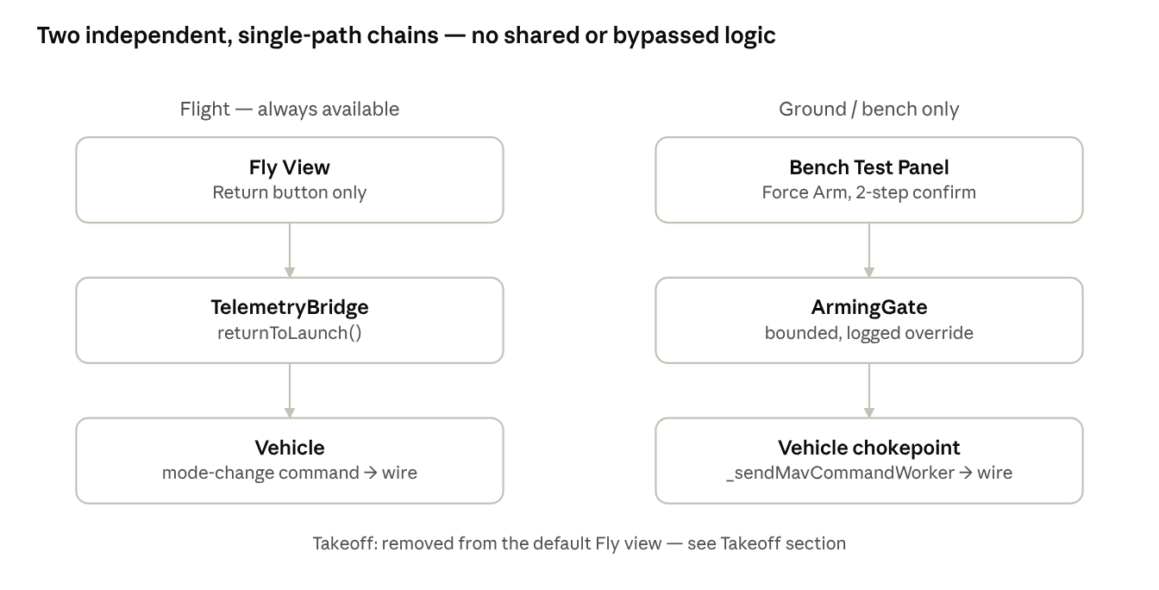
target architecture · 2 chains, 3 steps each
Return and Force Arm now run down two separate, single-purpose chains, with no shared code and no path that skips the gate.

Migration & Rollout Plan
Order matters here mainly so bench-test capability is never lost mid-migration, and so nothing gets marked done based on an edited file that turns out not to be the one the running app actually loads (see the MainStatusIndicator QML-shadowing finding under File-by-File Changes).
- Land RTL hardening and its single code path first — lowest risk, and it's the one control this spec keeps, so get it solid before touching the other two.
- Remove the Takeoff control from FlyQuickActions.qml — pure deletion, no new surface required first.
- Fix VehicleProfileManager::forceArm() and HardwareTestController's fixed-wing auto-arm to route through the bounded, logged override — this is a prerequisite for step 4's safety claims, not optional cleanup.
- Build the Bench Test panel with hardened Force Arm, using the now-consistent override path from step 3.
- Verify the Bench Test panel works end-to-end (motor spin test, control-surface sweep, force-arm with a failing mandatory check) before removing anything from the Fly view.
- Remove the Force Arm control and confirm dialog from FlyQuickActions.qml.
- Remove any residual force-arm affordance from MainStatusIndicator.qml, ArmedIndicator.qml, PreflightToolbarIndicator.qml.
- Add or extend telemetry-strip widgets per the Monitoring Surface section as capacity allows — this can ship incrementally and doesn't block the rest.
- Update the operator-facing runbook to reflect the new Fly view and where bench testing now lives.
At every step that touches a QML file with a stock counterpart, confirm with a sentinel log line (the technique already used to discover that the custom MainStatusIndicator.qml never loads in the running app) that the edited file is the one actually running — not just the one that compiles.

Test Plan
Suite / check | What it must show
ArmSendTest (a)/(b)/(c) | Gate-closed, override-open, and override-expiry behavior unchanged — the veto sits at the Vehicle-level chokepoint independent of which QML caller triggers it, so relocating the button shouldn't change these results
HardwareTestControllerTest | Extended: fixed-wing auto-arm now opens a bounded override before sending, closing the gap this spec's Force Arm section identifies
ControlSurfaceTestControllerTest | Extended: arm-before-sweep opens a bounded override before sending
MavLinkInterceptTest | Unaffected — remains scoped to inbound-only interception
New: QML smoke test on FlyQuickActions.qml | Asserts Force Arm and Takeoff controls are absent for default quad/FW vehicle kind; asserts RTL control is present and wired to a single function
New: Bench Test panel smoke test | Force-arm control present, two-step confirm required, refuses with non-zero groundspeed
New: sentinel/load-trace check | For every QML file this spec edits, confirms the running app loads the edited file rather than a stock counterpart — a standing regression check, not a one-off
Manual: bench verification | Force-arm from the new panel with a mandatory check failing opens the bounded override and sends exactly one arm command, mirroring ArmSendTest (b) through the new UI path
Manual: Fly view verification | Against the real running app — not just the test harness — confirm Force Arm and Takeoff are absent and RTL is present and functional

Open Questions
- Does any current or near-term ops profile actually need GCS-commanded takeoff (VTOL transition, scripted survey launch)? If yes, that's a separate follow-up spec for a gated "Autonomous Ops" mode — not something to build speculatively now.
- Should RTL be triggerable only by an observer role, or should the flying pilot also be able to trigger it from the GCS as a backup to their own RC?
- Where should the new Bench Test panel live in navigation — a new top-level page, or merged into the existing vehicle-management/maintenance page?
- This spec is scoped to quad/FW with RC as primary control. Does VTOL need its own version of this analysis, given PreflightManager and VehicleProfileManager already carry VTOL-aware logic?
- Should the bounded force-arm override window for bench testing use the same duration as the flight-context override, or does ground testing warrant a different (longer, or explicitly re-triggerable) window?

